**Experiment 4**

**Linear Regression**

**Linear Regression** is a machine learning algorithm based on **supervised learning**. It performs a **regression task**. Regression models a target prediction value based on independent variables.

**Linear Models**

The following are a set of methods intended for regression in which the target value is expected to be a linear combination of the features. In mathematical notation, if y^ is the predicted value.

y^(w,x)=w0+w1x1+...+wpxp

Across the module, we designate the vector w=(w1,...,wp) as coef_ and w0 as intercept_. To perform classification with generalized linear models, see Logistic regression.

**Ordinary Least Squares**

**LinearRegression** fits a linear model with coefficients w=(w1,...,wp) to minimize the residual sum of squares between the observed targets in the dataset, and the targets predicted by the linear approximation.

Mathematically it solves a problem of the form:

minw||Xw−y||22

**LinearRegression** will take in its fit method arrays X, y and will store the

coefficients w of the linear model in its coef_ member:

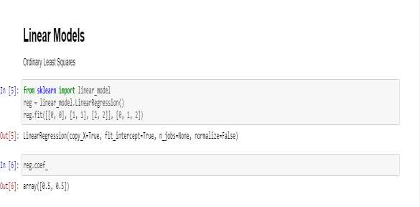

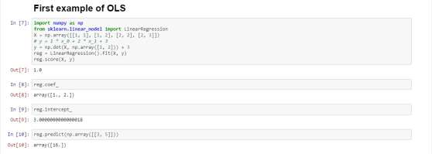

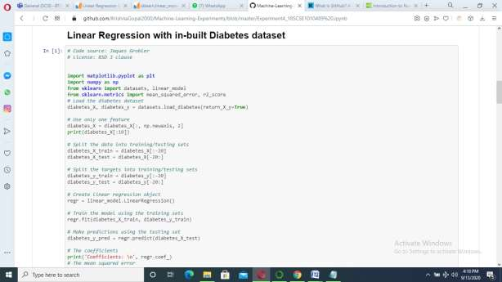

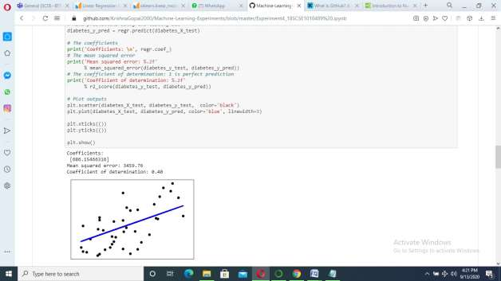

Change the feature:-

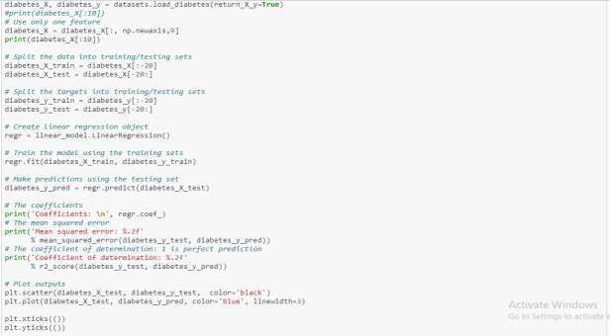

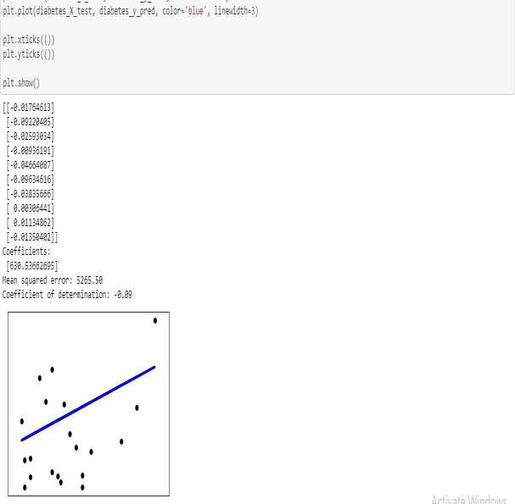

Increase the feature size:-

